Fundamentals of Cyber Security
The University of Toledo
(College of Engineering)
(EECS 4720/5720 – 001, 805)

Instructor: Ashish Kharel  Email: Ashish.Kharel@utoledo.edu  Office Hours: M,W: 1:30PM to 4:00PM  Office Location: NI 2022  Office Phone: (419) 530-8153  Term: Fall 2025  Course Website: Blackboard Learn | Class Location: NE2109  Class Day/Time: MW, 8.00 am – 9.20 am  Lab Location: None Day/Time: None  Credit Hours: 3

Hands-on 2

This hands-on is about understanding how buffer overflow attacks work. This was discussed in class this week. Please see PowerPoint PPTs, and the included links in the PPTs to help you understand more about buffers and stacks.
Please read all the sections below, then proceed to Task 1 to begin solving this hands-on. You can fill out your answers on the same document.

Introduction to Stack in Memory
For a typical C program, a computer memory is divided into five segments:
- Text Segment, which stores executable code
- Data Segment, which stores the initialized static/global variables
- BSS Segment, which stores uninitialized static/global variables
- Heap, used for dynamic memory allocation
- Stack, used for storing local variables defined inside functions and data related to function calls.
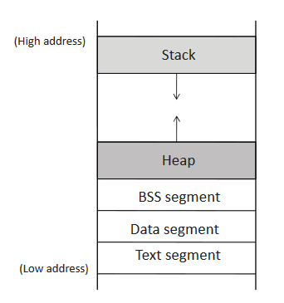

Figure 1: Stack in Memory Address Space

Stack is used for storing data used in function invocations. Consider this C function:

int main()
{
int a=5;
}

Since the variable ‘a’ is inside the function main(), it is stored in the stack memory. Stack is a LIFO based structure, and it goes from up to downward address space in memory. Stack pointer register stores the address of the top of the stack.

Stack Layout
Whenever a function is called, a block of memory space will be allocated on the top of a stack, known as stack frame. A stack frame has Arguments, Return Address, Previous Frame Pointer and Local Variables regions.
- Arguments region: It stores the values of the arguments that are passed to a function.
- Return Address: It is the address that is the processor returns to, after completing the function.
- Previous Frame Pointer: The next item pushed into the stack frame by the program is the frame pointer for the previous frame.
- Local Variables: Its size is dynamic, and is determined by compiler. It stores the function’s local variables.

Stack Control Flow
A stack holds many stack frames. Each stack frame holds the previous stack frame address as a return address of function. Since there is only one stack frame pointer register, it can only hold the current function stack frame. To make sure we return to the desired address after the function ends, the previous stack address is stored in Previous Frame Pointer field on stack.

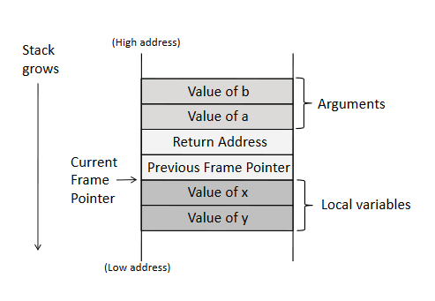

Figure 2: Stack Structure (a,b are arguments passed, and x,y are local variables)

Stack Behavior for Non-binary Buffer Size
Whenever the stack buffer size is not aligned with the data buffer size, the higher address above the stack buffer is overwritten with the data buffer. This causes the code to malfunction, because the return address is also overwritten.

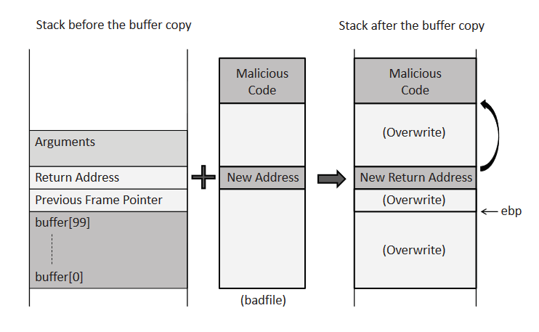

Figure 3: Non Binary Buffer Size Overwriting Address

Testing Program With Stack Buffer Overflow Vulnerability
Below is a C program to check if buffer-overflow vulnerability is present:

Table 1: Buffer overflow check code.
#include <stdio.h>
#include <string.h>

int main(void)
{
char buff[1];
int pass = 0;

printf("\n Please type any word of at least 2 characters: \n");
gets(buff);

if(strcmp(buff, "arandomkeywordhere"))
{
printf("\n \n");
}
else
{
pass = 1;
}

if(pass)
{

printf ("\n The system is vulnerable to buffer overflow\n");
}

return 0;
}

Since there is only one function in the program (int main) , there is only one stack frame.

Task 1: Install GDB on Kali Linux
Kali Linux by default doesn’t have GDB installed. Please install it with the following commands:
sudo apt update
sudo apt install gdb

Question 1: (1 point)
What is GDB?
GDB stands for GNU Debugger. It is a command-line tool that is used for debugging and analyzing programs. It can be used for running a program line by line, inspect variables and memory, pause execution to examine closely (set breakout points), examine stack, track down bugs/crashes, and analyze or conduct buffer overflow attack.

Task 2: Disabling ASLR
We have already learned about ASLR during our class.
Disable ASLR by using the following command:
sudo sysctl -w kernel.randomize_va_space=0

Question 2: (1 point)
What is ASLR? Why do we need to disable it for this hands on?
ASLR is address space layout randomization that randomizes address space locations at start, so the attacker can’t
know the address of the executable code to run malicious code. Even if the attacker tries brute force, they can’t exploit because each time the address space is changed; making the address list larger can make brute forcing even harder. We are disabling it to conduct a buffer flow attack. If the address is not randomized and we guess the address of the executable code, we can overwrite to it and conduct a buffer flow attack
Task 3: Compiling the code
Copy the entire program above to /home/kali/ location. Make sure the file is saved under filename vuln.c . You can use any text editor of your choice.

After saving the file, open Terminal on Kali Linux. Compile the file with the following command:
gcc -g -fno-stack-protector -z execstack -o -std=c99 -Wno-implicit-function-declaration -o vuln vuln.c (command 4)

Question 3: (1 point)
Explain the terms on the command (4). What is -o? What is -fno-stack-protector -z? Why is it needed? What is -std=c99? Why did we have to use it?
The command -o is the command that sets the output filename. Here the executable file name will be vuln. The -fno-stack-protector -z turns of the compiler’s stack canary protection. Stack canary is a random value that is placed between the local buffer (where data is held) and the return address. Compiler checks the value to ensure it hasn’t been changed, otherwise, a buffer attack has happened thus the function is aborted. It is needed here so it doesn’t assign and check the random value when we conduct the buffer overflow attack. The std=c99 command instructs the compiler to use the C99 standard (1999 C version). We use it here to avoid errors and allow compilers to accept newer features of C.
Question 4: (1 point)
After compiling the file, you must have gotten the following warning:
warning: the `gets' function is dangerous and should not be used.
Why is such warning provided by the compiler? What other functions in C language have similar vulnerability?
It is provided by the compiler because it can cause a buffer overflow attack. It will take input without limiting how many bytes it will write to the buffer. If it writes more than the buffer can handle, then a buffer flow attack can occur. Strcpy()—copies a string without checking destination size, strcat()—appends without checking space, printf, and sprintf

Task 4: Checking buffer overflow vulnerability
On the terminal type:
./vuln
After it asks you to type any word, type A. Press enter. Notice the result.

Again, on the terminal type:
./vuln
After it asks you to type any word, type AAAAAAAA. Press enter. Notice the result.

Question 5: (1 point)
What is the output after typing AAAAAAAA? Provide the screenshot.

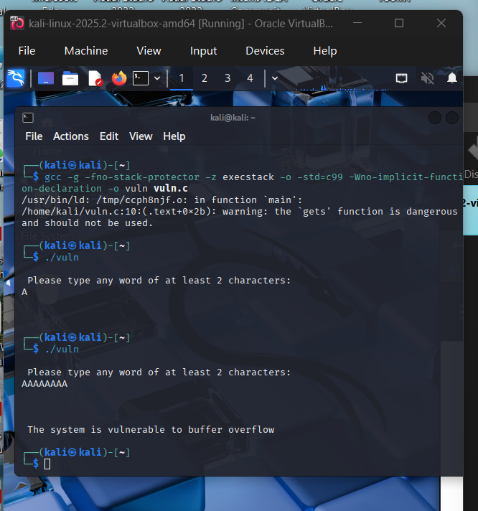

Task 5: Setting up breakpoint
On the terminal, type:
gdb vuln

Let’s set up a breakpoint at line 25 of our program. Line 25 is the line just after the final printf statement.
Type the following command inside gdb:
break 25
run
When it asks you to type any word, type AAAAAAAA again.

Question 6: (1 point)
What does it mean to set a breakpoint in a program?
A breakpoint means to pause the execution when it reaches a certain line, in this case, line 25. Then one can inspect program’s memory, variables, and process state at that line.

Task 6: Using GDB to peek into buffer and see what’s going on.
Type the following command:
x/50x $rsp
The output may be similar, but not same to the following screenshot:
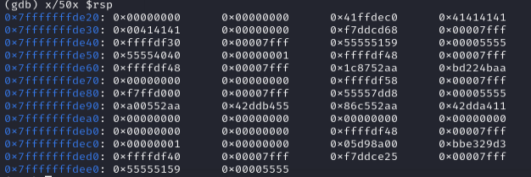
Figure 4: Contents of stack.

Remember that letter A is represented by 0x41 in HEX. You can see 8 A being written on some parts of first row and second row.

Question 7 (1 point)
Explain the command x/50x $rsp. What is x/50x?
The command x/50x$rsp printed the topmost 50 memory words on the stack in hexadecimal. X is examining gdb memory, /50 is showing 50 addresses from the address given (here $rsb is saying from the top), and x afterwards is telling to give the results in hexadecimal.

Now type:
info registers

Question 8: (1 point)
What is the meaning of rbp and rsp? What is the value for your rbp and rsp? (Note that some MAC systems might show eip, esp. That’s fine.)

Rbp=0x7fffffffdd70 –points to the base of the current function’s stack frame. It doesn’t move as the function is executed.
*for study purposes: a buffer is below the rbp and rbp is below the return address, so if one overwrites it, it can spill data into the return address and link to a malicious executable code.
Rsp=0xfffffffdd60—points to the top of the stack, the next available or last used location on the stack, also known as the stack pointer, it is also a moving pointer because every time something is added or removed, the top pointer changes.

Question 9: (2 points)
If you wanted to overwrite the return address such that your buffer-overflow attack would be successful, what would be the address you needed to target (return address in the stack)? Get a screenshot of x/50x $rsp
from Task 6 on your PC. Highlight that location on the screenshot by using pen/inking tool and paste it below. Note that to be able to answer this question, you are expected to study all the links provided on the PPTs and the background included with this Hands-on 2.

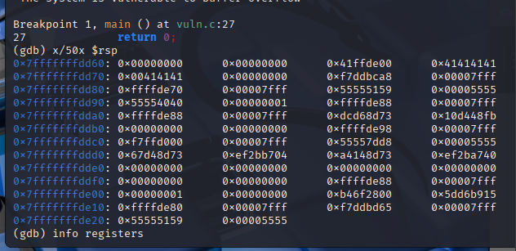

Question 10: Task 4, 5 and 6 won’t be graded if this is not answered. (Worth total 6 points). This is to ensure that you have not simply copied your friend’s work.
Open up TextEditor application on KaliLinux. Then write your full name. Then get a screenshot of question 9, along with your name on the TextEditor application. See an example below. Note my name on TextEditor.
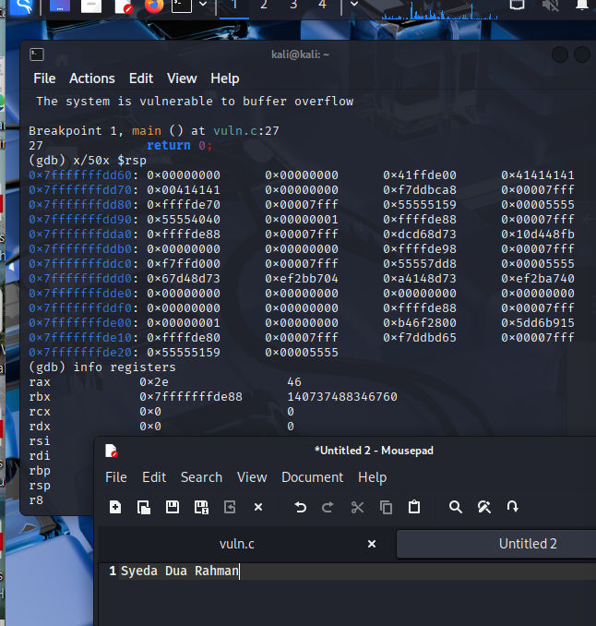
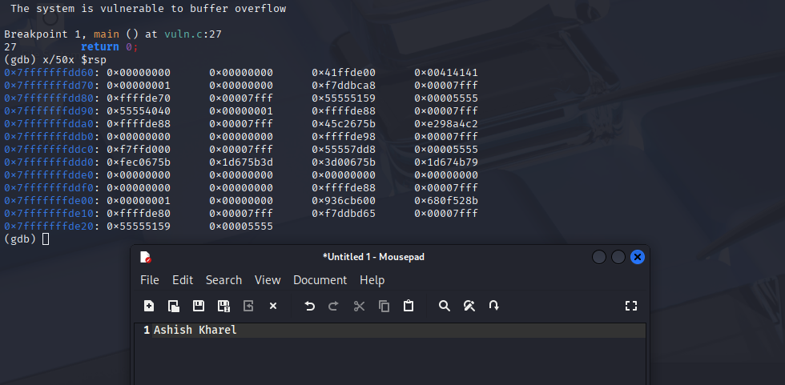

Submission:

Hands-on 2 will have to be submitted to BlackBoard so that it can be graded by the grader. The total points is 10. The penalty for late submission is 1 off each day. Plagiarism detection has been turned on.

You will need to answer all the questions in this report.

